This n That

An e-mail newsletter from Agapé Athletics Club

Editor: Marieta Bortoli 082 466 7031 11 September 2017 www.agape.org.za

E-mail: marietabortoli@gmail.com

NB

- Next league race – Jacaranda City Challenge – 14 October
- Agapé helpers race – 25 September
- Agapé race (Jacaranda City Challenge) – 14 October Members to assist. PLEASE DIARIZE !!!!!!

Editorial

As our race is a league race I urge club members please come and run our helper’s race on 25 September at 07h00. We will only be running/walking the 10km. We need all the points we can earn to stay in the top 10 of division 1. No entry fee is payable and the 25th is a public holiday.

Now that summer is on its way and members are starting to run more races maybe I will be lucky to receive some race reports. Please also send some photos taken at races.

Contents

# Birthday greetings
# Personalia
# Welcome new and former members
# Congratulations
# Thank you’s
# In the mailbox
# General
# Race reports / upcoming race information
# Race results
# Training/Health snippets
# Thought of the week
# Your smile for the week
# Something to ponder over / something spiritual
# AGN league logs
# Races cancelled
# Notice Board
# Photo corner

Notice Board Additions

● King Price Irene Farm Race

Attachments

●

Birthday Greetings
May the Lord bless you and send from above the peace of His presence, the joy of His love. May He grant you happiness in everything you do! Happy birthday!

Ignis Claase 11 September | Kiebet Strauss 11 September
Marix Venter 12 September | Donald Mahole 15 September
Mandy Atkins 21 September | Hercu Bloem 25 September
Mark van der Watt 25 September | Chris Burger 26 September
Fred Harding 27 September

Personalia

Welcome new and former members

Congratulations

Congratulations to the following members:

Thank you’s

In the mailbox

General
Clothing available:
Buffs @ R100
Ladies skirts @ R200
Second skins @ R170
Age tags @ R30

Please contact Marietjie if you wish to purchase some of the items:
Cell: 072 541 7268 E-mail: ventermarix9@gmail.com
The items will also be available at races, please visit our gazebo

Race reports/Upcoming race information

Race Results

Training/Health snippets

The stat of euphoria induced by prolonged exercise was known first as ‘second wind’ and more recently as ‘runner’s high’. Scientists originally attempted to explain the experience in terms of the ‘stress hormones’ adrenaline and noradrenalin. Then came the ‘endorphin hypothesis’. And now we have the ‘endocannabinoid hypothesis’: a suggestion that the physical and physiological wellbeing experienced by many endurance athletes is due to the exercise-induced activation of endogenous cannabinoids – lipids whose actions in the body resemble those of the active constituent of cannabis.

This theory, supported by scientific evidence that exercises boosts blood concentrations of endocannabinoids, is given a thorough airing in a review by US researches published in the British Journal of Sports Medicine. Their first point is that the endorphin hypothesis – that the runner’s high induced by the release of endogenous opioids in response to exercise – doesn’t hold water because, among other lesser reasons, these chemicals are simply too large to cross the blood-brain barrier and exert the central effects that are claimed for them.

The endocannabinoid hypothesis, on the other hand, is supported by the following observations:
- Unlike opioids, endocannabinoids can suppress pain at peripheral sites as well as centrally;
- Unlike opioids they do not produce such side effects as severe respiratory depression, pinpoint pupils and constipation;
- Endocannabinoids inhabit swelling and inflammation and reduce pain caused by the release of chemicals (such as lactic acid);
- The intense psychological experiences reported by users of cannabis – sedation, reduced anxiety, distortions of time estimation, euphoria, enhanced sensory perception and feelings of wellbeing – are strikingly similar to the experience of runner’s high;
- Research on animals has suggested that one of the principal roles of the endocannabinoid system may be the refinement of movements needed for coordinated locomotion;
- Activation of endogenous cannabinoids through exercise could account for the phenomenon of exercise addiction;
- Endocannabinoids act as vasodilators and bronchodilators, which should make exercise feel easier.

As the authors of the review point out: ‘Further research is necessary to characterise the precise nature of this endocannabinoid response to exercise, specifically the relative importance of factors such as the nature of the activity, exercise duration, exercise intensity, sex and age.’
But in the meantime they suggest that the endocannabinoid hypothesis is a feasible alternative to the endorphin theory and should be investigated as such.
Br J Sports Med 2004; 38:536 – 541

Nature and nurture in Ethiopian endurance running success
In the increasingly competitive world of international sport, identifying the key predictors of success has become a major goal for many sports scientists. And nowhere has the hunt been more focused than in East Africa, where the overwhelming success of male endurance athletes has kept the nature v nurture debate simmering. Saltin’s famous study comparing Kenyan and Scandinavian athletes suggested that it was the distance the Kenyans travelled to school on foot in childhood that gave them an edge in endurance athletics. That theory has now received further backing from a major British study comparing the demographic characteristics of Ethiopian athletes with non-athlete controls from the same country.

An additional fascinating finding was that elite Ethiopian distance runners are ethnically distinct from the general Ethiopian population, raising the possibility that genetic factors might also be involved.

Questionnaires seeking information on place of birth, spoken language (by self and grandparents), distance from and method of travel to school were given to 114 male and female members of the Ethiopian national athletics team and 111 Ethiopian controls, none of whom were regularly training for any track or field athletic events. The athletes were separated into three groups for comparison: marathon runners (34), 5-10km runners (42) and other track and field athletes (38).

After analysis, the main findings were as follows:
- In terms of regional distribution, there was a significant excess of athletes, particularly marathoners, from the Arsi and Shewa regions of Ethiopia. 73% of marathon runners hailed from one of these two regions, compared with 43% of 5-10km runners, 29% of track and field athletes and just 15% of controls. To put those figures in context, Arsi is the smallest of Ethiopia’s 13 regions, accounting for less than 5% of the population, but housing 38% of the marathon athletes in this study;
- The origin of language of all the athlete groups differed significantly from that of the controls. Three separate language categories were used: Semitic, Cushitic and Other; and Cushitic was significantly more predominant in each of the athlete groups than among the controls. The effect was most pronounced in the marathon group, where 75% spoke languages of Cushitic origin compared to 30% of controls;
- In terms of distance travelled to school, the marathon athletes differed significantly from all other groups. 73% of marathoners travelled more than 5k to school each day, compared with 32-40% of the other groups. And marathoners were much more likely to run to school each day than the other groups (68% v 16-31%).

Where does this leave the nature v nurture debate? The findings about travel to school undoubtedly point to environmental influences, as the researches acknowledge. ‘…the results implicated childhood endurance activity as a key selection pressure in the determination of Ethiopian endurance success,’ they say. ‘With the prevalence of childhood obesity in the United States and Great Britain at an all – time high, and physical activity levels among such populations in stark contrast to the daily aerobic activity of Ethiopian children, these factors may offer an explanation for the success of East-African athletes in the international stage.’

On the other hand, the findings about regional and ethnic origins point to the genetic influences. Or do they? The regions of Arsi and Shewa are situated in the central highlands of Ethiopia, intersected by the very same Rift Valley that has been implicated in the success of Kenyan endurance runners. This may seem to support a link between altitude and endurance success. But it doesn’t explain why Arsi is also considerably overrepresented in track and field athletes (18%), who would not be expected to benefit from living and training at altitude. The researchers put forward an alternative, somewhat more prosaic, hypothesis. ‘One of the senior Ethiopian athletic coaches informed the investigators that most of the marathon athletes would be found to be from Arsi,’ they explain. ‘If those in charge of athletic development believe this, it may cause a self-fulfilling prophecy through talent scouts focusing more attention to this region or through increased regional development of athletics.’
What are the findings about language? The fact that most of the marathoners spoke languages of Cushitic origin (mostly Oromigna, the language of Oromo people) ‘may reflect a high frequency of potential “performance genes” within this particular group.

‘However, it is much more likely, ‘the researchers add, ‘that the distinctive ethnic origin of the marathon athletes is a reflection of their geographical distribution, as primarily Oromo people populate Arsi. ‘Although not excluding any genetic influence,’ they conclude, ‘the results of the present study highlight the importance of environment in the determination of endurance athletic success.’
Med Sci Sports Exerc, vol 35, no 10, pp1727-1732

Your thought for the week

Challenges are what make life interesting and overcoming them is what makes life meaningful!

Your smile for the week

A blonde man is in the bathroom and his wife shouts: "Did you find the shampoo?"
He answers, "Yes, but I'm not sure what to do... it's for dry hair, and I've just wet mine."
==
A blonde man spies a letter lying on his doormat.
It says on the envelope "DO NOT BEND".
He spends the next 2 hours trying to figure out how to pick it up.
==
A blonde man was driving home, drunk as a skunk. Suddenly he has to swerve to avoid a tree, then another, then another.
A cop car pulls him over, so he tells the cop about all the trees in the road.
The cop says, "That's your air freshener swinging about!"
==
A blonde man is in jail. The guard looks in his cell and sees him hanging by his feet.
Just WHAT are you doing?" he asks.
Hanging myself, the blonde replies.
The rope should be around your neck" says the guard.
I tried that, he replies, "but then I couldn't breathe."
==
An Italian tourist asks a blonde man:
"Why do scuba divers always fall backwards off their boats?"
To which the blonde man replies: "If they fell forward, they'd still be in the boat."
==
Two blonde men find three grenades, and they decide to take them to a police station.
One asked: "What if one explodes before we get there?"
The other says: "We'll lie and say we only found two."

Something to ponder over / something spiritual
GOD LIVES UNDER THE BED
I envy Kevin. My brother, Kevin, thinks God lives under his bed. At least, that's what I heard him say one night.
He was praying out loud in his dark bedroom, and I stopped to listen, 'Are you there, God?’ he said. 'Where are you? Oh, I see. Under the bed...'
I giggled softly and tiptoed off to my own room Kevin's unique perspectives are often a source of amusement. But that night something else lingered long after the humour. I realized for the first time the very different world Kevin lives in. He was born 30 years ago, mentally disabled as a result of difficulties during labour. Apart from his size (he's 6-foot-2); there are few ways in which he is an adult.
He reasons and communicates with the capabilities of a 7-year-old, and he always will. He will probably always believe that God lives under his bed, that Santa Claus is the one who fills the space under our tree every Christmas and that airplanes stay up in the sky because angels carry them.
I remember wondering if Kevin realizes he is different. Is he ever dissatisfied with his monotonous life?
Up before dawn each day, off to work at a workshop for the disabled, home to walk our cocker spaniel, return to eat his favourite macaroni-and-cheese for dinner, and later to bed.
The only variation in the entire scheme is laundry, when he hovers excitedly over the washing machine like a mother with her new-born child.
He does not seem dissatisfied. He lopes out to the bus every morning at 7:05, eager for a day of simple work.
He wrings his hands excitedly while the water boils on the stove before dinner,
and he stays up late twice a week to gather our dirty laundry for his next day's laundry chores.
And Saturdays - Oh, the bliss of Saturdays!
That's the day my Dad takes Kevin to the airport to have a soft drink, watch the planes land, and speculates loudly on the destination of each passenger inside. 'That one's goin' to Chi-car-go! 'Kevin shouts as he claps his hands. His anticipation is so great he can hardly sleep on Friday nights.
And so goes his world of daily rituals and weekend field trips. He doesn't know what it means to be discontent…
His life is simple.
He will never know the entanglements of wealth or power, and he does not care what brand of clothing he wears or what kind of food he eats. His needs have always been met. He never worries that one day they may not be.
His hands are diligent. Kevin is never happier than when he is working. When he unloads the dishwasher or vacuums the carpet, his heart is completely in it.
He does not shrink from a job when it is begun and he does not leave a job until it is finished.
When his tasks are done, Kevin knows how to relax. He is not obsessed with his work or the work of others. His heart is pure.

He still believes everyone tells the truth, promises must be kept and when you are wrong, you apologize instead of argues.
Free from pride and unconcerned with appearances, Kevin is not afraid to cry when he is hurt, angry or sorry. He is always transparent, always sincere. And he trusts God.
Not confined by intellectual reasoning, when he comes to God, he comes as a child. Kevin seems to know God - to really be friends with Him in a way that is difficult for an 'educated' person to grasp. God is his closest companion. In my moments of doubt and frustrations, I envy the security Kevin has in his simple faith.
It is then that I am most willing to admit that he has some divine knowledge that rises above my mortal questions. It is then I realize that perhaps he is not the one with the handicap. I am.
My obligations, my fear, my pride, my circumstances - they all become disabilities when I do not trust them to God's care.
Who knows if Kevin comprehends things I can never learn? After all, he has spent his whole life in that kind of innocence, praying after dark and soaking up the goodness and love of God.
And one day, when the mysteries of heaven are opened, and we are all amazed at how close God really is to our hearts, I'll realize that God heard the simple prayers of a boy who believed that God lived under his bed.
Kevin won't be surprised at all!

League results

Standings after the Romans Pizza (Marcel van’t Slot) race:

Running
 | Romans Pizza | Div 1 | Points
July | Pos | Club | League
107 | 1 | VTM | 158
223 | 2 | PMMC | 149
123 | 2 | ACE | 149
151 | 4 | AGAPé | 119
80 | 5 | HQH | 117
35 | 6 | PvR | 113
160 | 7 | RESBANK | 103
100 | 8 | OVERKRUIN | 92
35 | 9 | NPO | 89
231 | 10 | RWFL | 79
152 | 11 | AURECON | 76
615 | 12 | IRENE | 74
182 | 13 | LOVE RUNNING | 70
160 | 14 | CSIR | 68
115 | 15 | AFFIES | 62
206 | 16 | PPMK | 56
41 | 17 | BMW | 34
35 | 18 | ARETE | 32
60 | 18 | RUN AT OUT | 28
35 | 20 | ENDURO | 3

Walking
Romans Pizza | + | Points
Pos | Club | L'gue
1 | IRENE | 155
1 | PMWC | 155
3 | RWFL | 147
4 | VTM | 128
5 | LOVE RUNNING | 122
6 | RWFL B | 116
7 | SOLIDARITEIT | 99
8 | AGAPE | 73
9 | TRANSNET | 64
10 | CORR SERV | 63
11 | MAGNOLIA | 61
12 | PPMK | 59
13 | TUKS | 56
14 | AURECON | 54
15 | BODYWALK | 53
16 | PHOBIANS | 51
17 | RESBANK | 40
18 | IRENE B | 35
19 | ACRW | 33
20 | RUNNING INN | 17

Super league
Romans Pizza | Female | Points |  | Romans Pizza | Male | Points
Pos | Club | Log |  | Pos | Club | Log
1 | IRENE | 373 |  | 1 | PMMC | 398
2 | TEAM VITALITY | 362 |  | 2 | ACE | 375
3 | VTM | 354 |  | 3 | IRENE | 361
4 | MAGNOLIA | 336 |  | 3 | NEDBANK | 361
5 | NEDBANK | 304 |  | 5 | CORR SERV | 358
6 | HQH | 286 |  | 6 | VTM | 344
7 | AGAPE | 277 |  | 7 | TUKS | 326
8 | TUKS | 263 |  | 8 | FARANANI | 316
9 | ACRW | 256 |  | 9 | ARCADIA | 300
9 | PHOBIANS | 256 |  | 10 | RWFL | 262
11 | KPMG | 249 |  | 11 | PPMK | 242
12 | GREEN MILE | 242 |  | 12 | MAGNOLIA | 238
13 | CSIR | 223 |  | 13 | PHOBIANS | 209
14 | RUNAVATION | 209 |  | 13 | TEAM VITALITY | 209
15 | AFFIES | 195 |  | 15 | CITY OF TSHWANE | 204
16 | PMMC | 180 |  | 16 | FORD | 192
17 | WINGATE | 160 |  | 17 | RUNNERS STORE | 184
18 | LOVE RUNNING | 152 |  | 18 | BOOT CAMP | 181
19 | PVR | 144 |  | 19 | MONACO | 158
20 | BOXER | 133 |  | 19 | KPMG | 158
21 | MONTANA | 126 |  | 21 | AURECON | 147
21 | ARCADIA | 126 |  | 22 | RUNAVATION | 142
23 | OVERKRUIN | 110 |  | 22 | CSIR | 142
24 | SOLIDARITEIT | 109 |  | 24 | SAPS ACADEMY | 138
24 | CORR SERV | 109 |  | 25 | LOVE RUNNING | 123
26 | AKASIA | 103 |  | 26 | BOPHELONG | 119
27 | FPN | 98 |  | 26 | HQH | 119
28 | AURECON | 96 |  | 28 | A4A | 117
29 | PPMK | 90 |  | 28 | RESBANK | 117
30 | ACE | 88 |  | 30 | AGAPE | 107

Cancelled Races
- Lester Mills Night Race - 20th September 2017
- City to City – 24 September 2017
- Kolonnade Retail Park - 11 November 2017

Notice Board

Useful Links:
www.raceresults.co.za/flyers - for the latest race pamphlets
www.agn.co.za/#League for the latest league logs and the league points you earned
http://www.agn.co.za/Docs/2016/WAlking/AGN%20road%20walking%20stds%20ref%20685.pdf
AGN 2016 RW qualifying standards and selection criteria
www.runawaysport.co.za Run-A-Way Sport’s web site
www.verticalhorison.co.za Trail Running www.trailseries.co.za Trail Running
http://www.mastersathletics.net/Age-Graded-Calculator.2595.0.html Age Graded Calculator
http://www.sportsinjuryclinic.net/symptom-checker By clicking where it hurts then ticking which symptoms most apply to you we can give you an indication of what injuries may apply.

21.1km AGN Race Walk Championship
Saturday 16 September Brooklyn Road Race 21.1/10/5 km
Race Organisers: Pretoria Marathon Club
Venue: Brooklyn Mall, c/o Veale & Bronkhorst Streets, Brooklyn

 | 21.1 km | 10 km | 5 km
Entry-fee | R 100 | R 80 | R 40
70+, wheelchairs, blind runners | Free (race day only)
Start Time | 06:00 |  | 06:10
Cut-off | 03:00 |  | 02:00

No animals allowed
Baby strollers welcome on the 5km race
Wheelchair athletes welcome in all races
Free t-shirts to 1st 100 on line entries

Pre-entries at: Run-away Sport; Sweatshop Southdowns, Dunkeld & Fourways Crossing; Runners Store
www.enteronline.co.za

Saturday 23 September Bophelong Road Race 21.1/10/5 km
Race Organisers: Bophelong Athletics Club
Venue: Bophelong Community Centre, 19477 Molepo Street, Mamelodi East
GPS: S 25.7168 E 28.3769

 | 21.1 km | 10 km | 5 km
Entry-fee | R 90 | R 70 | R 50
Start Time | 06:00 |  | 06:15
Cut-off | 03:00

Route not wheelchair friendly

Pre-entries at: Run-away Sport; Runners Store

www.entrytime.com

Monday 25 September The Combat Run 21.1/10/5 km
Race Organisers: Titans Lifestyle Club & Armscor Athletics Club
Venue: Gerotek Test Facilities, R104 WF Nkoma Street, Pretoria West (13km outside Pretoria CBD)
GPS: S 25.45.515 E 28.00.522

 | 21.1 km | 10 km | 5 km
Entry-fee | R 90 | R 70 | R 50
Start Time | 06:00 |  | 06:30
Cut-off | ??:00

There is also a 6 & 12 km trial run (R70 & R90)

Pre-entries at: Runners Store; Sweatshop South Downs

AGN 21.1km Championships
Saturday 30 September Clover Irene Spring Race 21.1/10/5 km
Race Organisers: Irene Athletics Club
Venue: Irene Village Mall, c/o Nelmapius & Van Ryneveld Avenue, Irene

 | 21.1 km | 10 km | 5 km
Entry-fee | R 90 | R 70 | R 40
60+ | R 50
70+ | Free
Start Time | 06:00 |  | 06:10
Start Time – Walkers / wheelchairs | 05:45
Cut-off | 03:30

Route is wheelchair friendly
Pets allowed on the 5km

Pre-entries at: Run-away Sport; Total Sports Irene Village Mall; Sweatshop Southdowns, Dunkeld, Broadacres & Bedfordview

www.enteronline.co.za & www.irenevillagemall.co.za
Saturday 7 October Chamberlain Capital Classic 21.1/10/5 km
Race Organisers: Phobian Athletiics Club & Alpha Centurion Runners/Walkers
Venue: Phobians Club, Queens Crescent, Lynnwood
GPS: S 25.45’64.4 E 28.15’22.8

 | 21.1 km | 10 km | 5 km
Entry-fee | R 90 | R 60 | R 40
Blind athletes, 70+, 80+ - race day only | Free
Start Time | 06:00 |  | 06:15
Cut-off | 03:30

Wheelchair & baby strollers welcome

Pre-entries at: Run-away Sport; Runners Store; Sweatshop Southdowns & Dunkeld
Chamberlains – Centurion, Montana Megastore, Silver Lakes Megastore, Waterkloof Glen & Riviera

www.enteronline.co.a

League Race
Saturday 14 October Jacaranda City Challenge 42.2/21.1/10/5 km
Race Organisers: Agapé Athletics Club & Sportsvendo
Venue: SABS Grounds, 1 Dr Lategan Road, Groenkloof
GPS: S 25 46’ 10” E 28 12’ 42”

 | 42.2km | 21.1km |  | 10 km | 5 km
Pre-entry fee (until 5 October) | R 150 | R 80 |  | R 70 | R 30
Entry fees 60 – 79 | R 80 | R 50 |  | R 40
Late entry fees (13/14 October) | Closed | R100 | R 80
Late entry fees 60 - 79 | Closed | R 50 | R 40
Jardine Joggers / 80+ athletes | Free
Start Time | 05:45 |  |  | 06:15 | 06:30
Time Limit | 05h:30 | 03h00 | 2h00

Free t-shirts to the 1st 5000 pre-entries

Chip results – no tear-off – no results

Pre-entries: Run-A-Way Sports; Sweatshop Dunkeld, Bedford & Southdowns, Randburg Runner; Sportmans Warehouse Atterbury value Mart, Centurion Value World & Kolonnade Retail Park;

Enter on line: www.entrytime.co.za

Saturday 21 October CSIR Race 21.1/10/5 km
Race Organisers: CSIR Athletics CLub
Venue: CSIR, North gate, off Meiring Naude Rd, Brummeria
GPS: S 25 44.874 E 28 16.523

 | 21.1 km | 10 km | 5 km
Entry-fee | R100 | R 80 | R 40
Entry fee 70+ | Free
Start Time | 06:00 |  | 06:05
Cut-off | 03:00
No wheelchairs or prams – course unsuitable

Pre-entries at: Run-away Sport; Sweatshop Centurion
Also at CSIR Wednesday – Friday 18-20 October 17h00 – 19h00 Sports hall, South gate

www.entrytime.com

Saturday 28 October King Price Irene Farm Race 21.1/10/5 km
Race Organisers: Irene Athletics Club
Venue: ARC Irene Campus, Nellmapius Drive, Irene

 | 21.1 km | 10 km | 5 km
Entry-fee | R 90 | R 70 | R 40
Entry fee 60+ (Race day only) | R 50
Entry fee 70+ (Race day only) | Free
Start Time | 06:00 – run  05h45 - walk |  | 06:00
Cut-off | 03:30 | 02:00

There is a kiddies run @ R10 @ 08h00
No pets allowed
21.1km is not wheelchair friendly

Pre-entries at: Run-away Sport; Sweatshop Southdowns, Dunkeld, Boardacres & Bedfordview

2017 AGN LEAGUE FIXTURE LIST
EVENT | DISTANCE | DATE | LEAGUE
 |  |  | RR | RW
Jacaranda Challenge | 10 / 21.1 / 42.2 km | 14/10/17 | X | X
Kolonnade Retail Park Race cancelled | 10 / 21.1 km | 11/11/17 | X | X

Masters Athletics Fixture list

Local meetings
? Sept/? October 2017 SWD Oudtshoorn
11 November 2017 Free State Bloemfontein

Time Trials:

Centurion -
Lewende Woord Centurion on Wednesdays at 17:30
Contact Marinda 654 5800 (h) 082 720 9017

Rietondale –
North Street, Rietondale (Rietondale Park in the street before the Crawford Stadium) Thursdays 17:30
Contact Dorothy Benadie 082 704 2300 dorothy.benadie@gmail.com or
Hennie Venter 083 702 4472

Zita Park - Tuesdays at 17:30
Zita Street, Zita Park, Garsfontein
Contact Hennie Venter – 083 702 4472 Marietjie Venter – 072 541 7268

Gazebo Enquiries

Hennie Venter – 083 702 4472 Marietjie Venter – 072 541 7268

Intercessor:



Fred Harding 076 777 7786

Agapé Executive 2016/2017

Name | Position | Telephone number | E-mail address
Marieta Bortoli | Chairperson & editor | 012 331 2089  082 466 7031 | marietabortoli@gmail.com
Hennie Venter | Registrar & club captain | 083 702 4472 | henniev@seng.co.za  join@agape.org.za
Marilett Jenkins | Secretary | 082 837 2142 | marilett.jenkins@mervitzmalan.co.za
André Breytenbach | Treasurer | 083 566 1090 | andreb@geoscience.org.za
De Wet de Beer | PRO & vice-chairman | 082 373 2987 | dewet@styletechnique.co.za
Kobus Stander | Race organiser | 082 688 6697 | CLK1560PHARM@clicks.co.za
Fred Harding | Intercessor | 076 777 7786 | fredharding@telkomsa.net
Marietjie Venter | General activities & clothing co-ordinator | 072 541 7268 | Ventermarix9@gmail.com
Gustav Brink | Statistician | 083 417 8431 | gustav.brink@gmail.com

Photo corner

Agapé Executive

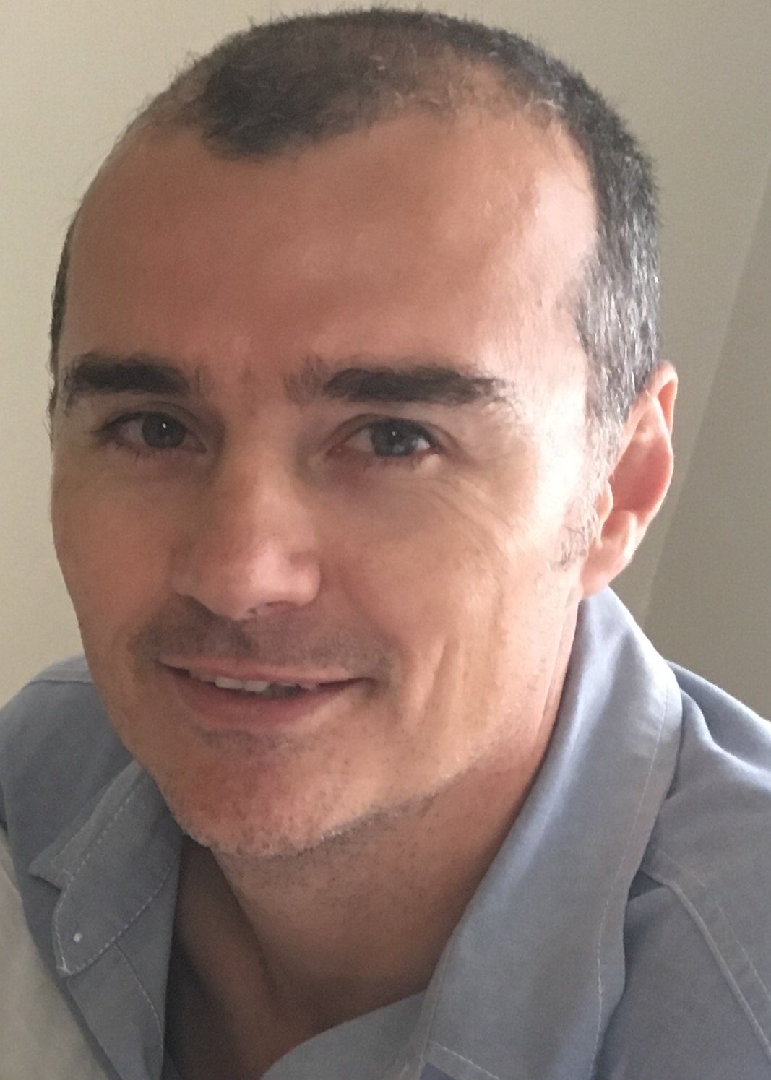

Marieta Bortoli Marilett Jenkins De Wet de Beer

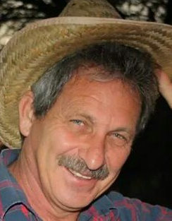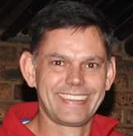
Hennie Venter André Breytenbach Kobus Stander

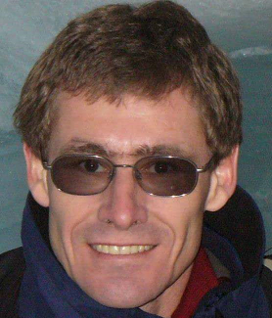
Marix Venter Fred Harding Gustav Brink (Ex-officio)

